UNDERGRADUATE PROJECT REPORT

Project Title | Insert your project topic here. It can extend to the
Project Title | second line if your topic is very long.
Student ID
Supervisor Name
Student Name
Student Major

Date Submitted

Declaration
Chengdu University of Technology Oxford Brookes College
Chengdu University of Technology

BSc (Single Honours) Degree Project
Programme Name:
Module No.:
Surname:
First Name:
Project Title:
Student No.:
Supervisor:
2ND Supervisor (if applicable): Not Applicable

A report submitted as part of the requirements for the degree of BSc (Hons) in Computer Science
At
Chengdu University of Technology Oxford Brookes College

Date Submitted：May 6, 2026

Student Conduct Regulations
Please ensure you are familiar with the regulations regarding Academic Integrity. The University takes this issue very seriously, and students have been expelled or had their degrees withheld for cheating in assessments. Students experiencing difficulties with their work must seek help from their tutors rather than being tempted to use unfair means to gain marks. Students should not risk losing their degree and undermining all the work they have done towards it. You are expected to have familiarised yourself with these regulations. https://www.brookes.ac.uk/regulations/current/appeals-complaints-and-conduct/c1-1/
Guidance on the correct use of references can be found on www.brookes.ac.uk/services/library, and also in a handout in the library. The full regulations may be accessed online at https://www.brookes.ac.uk/students/sirt/student-conduct/. If you do not understand what any of these terms mean, you should ask your Project Supervisor to clarify them for you.
I declare that I have read and understood Regulations C1.1.4 of the Regulations governing Academic Misconduct and that the work I submit is fully in accordance with them.
Signature: |  | Date:
Regulations Governing the Deposit and Use of Oxford Brookes University Modular Programme Projects and Dissertations
Copies of projects/dissertations, submitted in fulfilment of Modular Programme requirements and achieving marks of 60% or above, shall normally be kept by the Oxford Brookes University Library.
I agree that this dissertation may be available for reading and photocopying in accordance with the Regulations governing the use of the Oxford Brookes University Library.
Signature: |  | Date:

Acknowledgement
I want to thank my supervisor first. From picking the topic to arguing about the architecture to rereading the final draft, my supervisor gave me specific, actionable feedback at every stage. One moment stands out: an early version of the code had business rules spread across templates, and the suggestion to move them into a service layer changed the project. After that refactor the code got noticeably cleaner, and adding new features stopped feeling like pulling teeth. That small thing taught me "code that reads well" is harder than "code that runs".
Thanks also to the lecturers I had over four years in the Computer Science programme at Chengdu University of Technology Oxford Brookes College. You can trace almost everything in this project back to the foundation they laid — software engineering, data structures, web development, databases. Studying under a joint Chinese-British programme meant juggling English textbooks and more practice-focused Chinese material, and that mix helped me while writing this report.
Thanks to the five students who tested the platform for me. Their reactions shaped real decisions. Defaulting the Condition radio to "Like New" and adding a character counter to the description field both came from their suggestions. Thanks to my family for putting up with four years of this, including the weeks I spent debugging WebSocket connections at 2 a.m.
Finally, a genuine thank you to the maintainers of Flask, SQLAlchemy, Flask-SocketIO, Werkzeug, Pillow, and the other open-source projects this work stands on. There is no way one person builds something with this feature set in 14 weeks without that foundation.

Abstract
Every graduation season, dormitories fill up with old textbooks, outdated electronics, and furniture that does not fit in a suitcase. Sellers cannot find buyers and buyers cannot find sellers, so a lot of these items end up in the trash. The common workarounds — posts in WeChat groups, stalls outside the dorm, listings on general platforms like Xianyu and Zhuanzhuan — either reach too few people or ignore the two things that actually matter on campus: verifying that the other party is a student, and making face-to-face pickup painless. This project designs and implements TradeHub, a C2C second-hand web platform aimed squarely at college students, to close that gap.
The platform is written in Python 3.13. The backend is Flask 3.0 with SQLAlchemy 2.0 as the ORM; SQLite runs locally during development. The front-end is server-rendered Jinja2 templates plus a little vanilla JavaScript, with no webpack, no vite, and no ``npm install``. Real-time messaging between buyer and seller goes over WebSocket using Flask-SocketIO. The backend is split into eight Blueprints by business domain: registration and login, product CRUD, search and category filters, the wishlist, the order state machine, seller-accept and buyer-complete, star ratings, real-time chat, and the personal dashboard. Passwords are stored as PBKDF2 salted hashes via Werkzeug, every POST form carries a CSRF token, and the order state machine is guarded at both the service and database layers.
One person built the whole thing in 14 weeks. All 11 integration tests pass. A hands-on round of user testing with five classmates turned up only minor usability issues, and those were fixed in later iterations. Compared with mainstream e-commerce platforms, what makes TradeHub its own thing comes down to three things: interaction details tuned for campus use, a visual identity that is not borrowed from any default framework, and a front-end with no build toolchain — the last point matters because the project has a real chance of outliving its original author, rather than becoming another dead link in the campus website directory.
Keywords: Campus Second-hand Trading; Flask; SocketIO; C2C; Real-time Messaging; Reputation System

Abbreviations
The English abbreviations used in this thesis and their full meanings are listed in the table below. All abbreviations are arranged in alphabetical order.
Abbreviation | Full Meaning
C2C | Consumer to Consumer
CRUD | Create / Read / Update / Delete
CSRF | Cross-Site Request Forgery
GUI | Graphical User Interface
HTTP | HyperText Transfer Protocol
IDE | Integrated Development Environment
JSON | JavaScript Object Notation
MVC | Model–View–Controller
ORM | Object Relational Mapping
REST | Representational State Transfer
SPA | Single Page Application
SQL | Structured Query Language
UI | User Interface
UX | User Experience
WSGI | Web Server Gateway Interface

Glossary
This section lists the key terms used in this thesis along with their definitions, to help readers better understand the content.
Term | Definition
Blueprint | Flask's way of organising code. You can group routes, views, templates and static assets for one business domain and register the whole thing on the application factory. This project has eight of them.
Reputation System | Star rating plus text feedback on completed orders. A buyer who has a completed order can leave one review, and reviews accumulate on the seller's public profile.
Order State Machine | Legal transitions between the states pending, confirmed, completed, cancelled and rejected. Any illegal jump is rejected in the service layer before it reaches the database.
Real-time Messaging | WebSocket-based full-duplex connection. Compared with polling, a new message typically arrives within tens of milliseconds of being written to the database.
Wishlist | A list of products a user has bookmarked but not yet ordered. In the database it is a join table with a UNIQUE constraint on (user_id, product_id), so tapping the heart icon twice simply removes the entry.
Application Factory | A Flask convention: instead of writing ``app = Flask(__name__)`` at import time, define a ``create_app(config_name)`` function that builds the instance. The same code then runs under the dev, test and prod configurations.
CSRF Token | A random per-session string the server expects in every POST form. The server verifies it before acting, so a third-party site cannot forge a request on the user's behalf.
PBKDF2 | A password hashing scheme. You add a random salt, then iterate the hash many times so brute-force attacks become impractical. It is the default in Werkzeug.

Table of Contents
目录
Declaration I
Student Conduct Regulations II
Acknowledgement IV
Abstract V
Abbreviations VI
Glossary VII
Table of Contents VIII
Chapter 1. Introduction 1
1.1 Background of Study 1
1.2 Project Aim 1
1.3 Project Objectives 2
1.4 Project Overview 2
1.4.1 Scope 2
1.4.2 Audience 3
1.5 Structure of the Project Report 3
Chapter 2. Background Review 6
2.1 Fundamental Description of Software 6
2.2 Background Review 6
2.2.1 Comparative Analysis of Software Features 6
2.3 Limitations of Existing Works 7
2.4 Summary 8
Chapter 3. Methodology 9
3.1 Problem Statement 9
3.2 Approach 9
3.2.1 Software Development Method 9
3.2.2 Requirements Gathering 10
3.2.3 Testing and Evaluation Techniques 10
3.3 Technology 11
3.4 Project Version Management Plan 15
3.5 Summary 16
Chapter 4. Implementation and Results 17
4.1 Deployment Environment Details 17
4.2 Unit Test 18
4.2.1 Unit Test for Login System 18
4.2.2 Unit Test for Registration System 19
4.3 Integration Tests 19
4.4 Software Graphical Interface 20
4.4.1 Home Page and Product List 20
4.4.2 Product Detail Page 21
4.4.3 Publish Listing Page 22
4.4.4 Order Management Page 23
4.4.5 Real-time Chat Page 24
4.4.6 User Dashboard 25
4.4.7 Key Algorithms and Equations 26
4.5 Summary 26
Chapter 5. Professional Issues 27
5.1 Project Management 27
5.1.1 Activities 27
5.1.2 Schedule 28
5.1.3 Project Data Management 28
5.1.4 Project Deliverables 28
5.2 Risk Analysis 29
5.3 Professional Issues (Legal / Social / Ethical / Environmental) 30
5.4 Summary 31
Chapter 6. Conclusion 32
6.1 Findings and Conclusions 32
6.2 Limitations of the Project 33
6.3 Potential Future Work 34
References 35
Appendices 37
Appendix A. Project Directory Structure 37
Appendix B. Key Dependency List 37
Appendix C. Demo Accounts 38

Chapter 1. Introduction

1.1 Background of Study
Walk around any campus before graduation and you will notice a pattern. Textbooks that no one needs any more, laptops that have been replaced, monitors that will not fit in a checked bag. Published estimates put the second-hand goods circulating through Chinese campuses each year in the tens of billions of yuan. A single four-year undergraduate typically accumulates 20 to 30 textbooks, a couple of laptops or iPads, headphones, a monitor, and some dorm furniture. Most of that is still usable — it is just no longer useful to the original owner.
How do these items actually move, though? Mostly through pretty primitive channels. A photo in a WeChat friend circle. A post in the class group. A stall outside the dorm during graduation week. The common problem is reach: the thing I want might be two buildings over, and I have no way to know. Somebody's old camera might be exactly what I am after, but they only posted it to 200 people. A sizeable fraction of still-usable items ends up in the bin or sold at throwaway prices. It bothered me.
General platforms like Xianyu and Zhuanzhuan help, but only so much. They are perfectly capable products for the wider public. On campus they feel slightly off. Trust between strangers ends up leaning on Alipay's escrow, and that workflow is built for shipping-based deals. When the real scenario is "meet at the dining hall in five minutes", escrow is overkill. The platform also has no way of knowing that we are at the same school or even in the same dorm building — useful context it simply cannot exploit.
Those observations are what started this project. I wanted to see if I could build something aimed at the campus case specifically.

1.2 Project Aim
The target I set for myself: build a lightweight C2C web platform for college students that covers the full trade loop end to end, with real-time chat and a rating system wired in. Features should be reasonably complete, the flow should be smooth, and the architecture should hold up to a fair amount of scrutiny.

1.3 Project Objectives
To hit that aim, here is what I need to get done:
1. Look at the mainstream second-hand platforms (Xianyu, Zhuanzhuan, Kongfuzi and a few others) and figure out which features are table stakes and which ones do not carry over well to campus use.
2. Do the requirements analysis and database design: who the users are, what they can do, and how the core entities (users, products, orders, messages, reviews, wishlists) relate.
3. Implement the 8 backend Blueprints: registration and login, product CRUD, search and filtering, the order lifecycle, real-time chat, reviews, wishlists, and the personal dashboard.
4. Get WebSocket-based chat working on top of Flask-SocketIO, including unread counts and per-conversation message routing.
5. Build the front-end: 17 Jinja2 templates plus vanilla JavaScript and a hand-written CSS design system, with a visual identity that is recognisably its own.
6. Write unit and integration tests that cover the main business paths end to end.
7. Write this report in the format the institution requires, plus the accompanying demo materials.

1.4 Project Overview
The platform is called TradeHub. The positioning is "a lightweight C2C second-hand trading web app for the campus case". Once someone signs up with an email, they are both a buyer and a seller: browse, search, bookmark, order, review; also post items, manage orders, and chat. Architecturally it is classic MVT (Model–View–Template). Everything happens in the browser. No client install, no separate mobile app.

1.4.1 Scope
This version covers: listing a product, browsing and searching, wishlisting, placing an order, the seller accepting or rejecting, buyer-seller chat, completing the order, and the buyer leaving a review. Supporting pages are the personal dashboard, the public profile, and the product detail page. Online payment, logistics, advertising, and recommendation algorithms are out of scope for this version, mainly because of time. I have parked them in the future work section.

1.4.2 Audience
The target users are undergraduate and graduate students. As buyers they care about price, seller reputation, and how convenient pickup is. As sellers they care about how quickly they can list something, how easy it is to keep track of orders, and how smooth the conversation with the buyer feels. The campus is also full of lecturers and postgraduate family residents who could plausibly use this. I designed the interactions assuming a few things about the student audience: they notice response latency, they are picky about interface aesthetics, and they do nearly everything on their phones.

1.5 Structure of the Project Report
The report has six chapters. Figure 1-1 shows how they fit together.
Chapter 1 sets the scene — background, aim, broken-down tasks, scope. Chapter 2 looks at comparable platforms and what they get right or wrong for campus use. Chapter 3 is about the method: development style, requirements gathering, testing, technology choices, version management. Chapter 4 is the actual implementation and what it looks like running, with deployment details, tests, and interface screenshots. Chapter 5 steps back and reflects — project management, risk analysis, and the legal, social, ethical and environmental angles. Chapter 6 wraps up what I learned, where the project falls short, and where I would take it next.
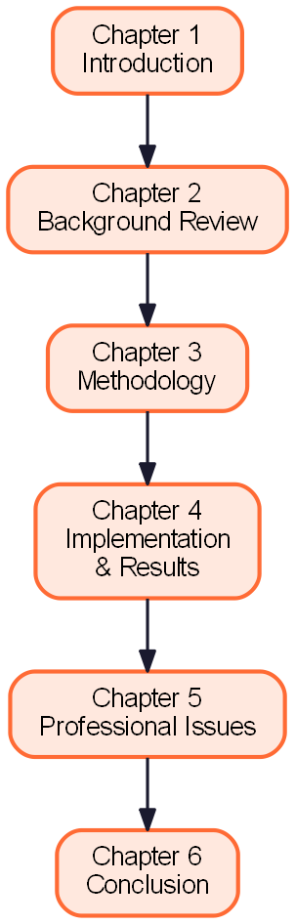
Figure 1-1. Thesis Structure Flowchart

Chapter 2. Background Review

2.1 Fundamental Description of Software
C2C (Consumer to Consumer) means individuals selling to other individuals through a third-party platform. Unlike B2C, where the platform itself stocks inventory, a C2C platform is a matchmaker: it brokers information, underwrites a bit of trust, and mediates when things go wrong. eBay and Craigslist in the US, Mercari in Japan, Xianyu and Zhuanzhuan in China all fit that mould. A few things they have in common: both sides are individuals; the platform charges brokerage rather than taking the margin on goods; and trust has to come from user-generated reputation, since there is no brand to lean on the way B2C does.
The usual implementation story on platforms at real scale is a split front-end and back-end plus a microservice backend: a single-page React or Vue front-end talking to dozens of services owned by different teams. That architecture matches users in the millions and engineers in the hundreds. It does not match the campus case, where the user base is capped, the business rules are simple, and over-engineering just piles on operating cost. Picking Flask and server-side rendering was a conscious call: I wanted this project to be maintainable by one person for four years, rather than collapse the moment I graduate.

2.2 Background Review
This section picks a few representative second-hand platforms for a feature-by-feature comparison, to pin down the places where campus users are not being served well. Those gaps become the justification for the design decisions in the next chapter.

2.2.1 Comparative Analysis of Software Features
To keep the comparison honest I picked four products across three categories: generalist platforms (Xianyu, Zhuanzhuan), a vertical second-hand book platform (Kongfuzi), and a campus forum flea-market board. The dimensions are identity verification, category granularity, real-time chat, reputation, geographic filtering, and how well they fit the campus case. Table 2-1 has the full matrix.
The picture that comes out: generalists have the most features but almost nothing for campus identity; vertical platforms go deep but only within their niche; campus forums feel close to the user but are usually primitive, with no reputation system to speak of. TradeHub is not trying to compete with any of these directly. It is trying to take these observations and lean hard into the "campus" context that the other tools under-exploit.
Table 2-1. Comparison of Existing Platforms
Platform | Identity | Categories | Real-time chat | Reputation | Geo filter | Campus fit
Xianyu | Phone | Fine | Yes | Sesame Credit | City | Weak
Zhuanzhuan | Phone | Medium | Yes | Platform rating | City | Weak
Kongfuzi | Phone | Fine (books only) | Yes | Platform rating | None | Medium
Univ. forum flea board | Student ID | Coarse | No | None | Campus | Strong
TradeHub (this work) | Email + Student ID | 6 categories | Yes (WebSocket) | Stars + comments | Campus zone | Strong

2.3 Limitations of Existing Works
Existing platforms share a handful of gaps when it comes to campus second-hand trading. I grouped them roughly like this.
First, identity trust. A generalist platform cannot verify that you are a student. So when two campus users trade on such a platform they fall back to Alipay escrow, which was designed for shipping-based sales and feels unnecessarily heavy for a "meet you at the dining hall in five" trade.
Second, geographic context. Buyer and seller are often in the same building, yet have to describe their locations in free text — "south zone dorm 3" or "north zone dorm 5" — which is slow and error-prone. A campus platform can naturally offer "same school" or "same dorm cluster" filters. None of the existing platforms do.
Third, fragmented communication. Product detail lives in one app, haggling happens in another, and payment is a third. A single transaction can spread across three tools, and important context — the price you agreed on, the pickup time — gets lost in the switching.
Fourth, missing campus-specific semantics. Textbooks need to match by course code and edition. Electronics need a field for whether the original receipt is included. Dorm furniture needs one for lift-accessibility. On generalist platforms all of this gets stuffed into free text where it cannot be searched or filtered.
Fifth, maintenance cost. Plenty of existing campus projects reach for microservices or heavy front-end toolchains; the original author graduates, nobody else wants to touch it, and the project quietly becomes a dead link in the campus directory. That is an organisational problem more than a technical one, but deliberately picking a light stack makes it much less likely to happen.
Sixth, mobile experience. A lot of campus projects are built desktop-first with responsive tweaks bolted on later. Most student users basically live on their phones. That priority is backwards.
I took all of the above into account when designing TradeHub: every user is a registered campus user; chat and orders share the same app; the publish form has fields shaped for campus categories; the responsive layout is mobile-first; and the stack is kept light from day one.

2.4 Summary
This chapter introduced the basics of C2C e-commerce and its usual implementation pattern, compared four representative platforms, and catalogued six common gaps in the campus case. Those gaps are what the next chapter's technology choices have to answer to.

Chapter 3. Methodology
This chapter walks through the method: what the problem is, the development style I used, how I gathered requirements, how I tested, how I picked the tech stack, and how I managed the code.

3.1 Problem Statement
Boiled down from the six gaps at the end of Chapter 2, the core question becomes:
"How do I build a lightweight web platform — aimed at the campus case, covering the full C2C loop, with real-time chat and a reputation system — that one person can actually keep maintaining?"
Three pairs of tensions come with that question. One is feature completeness against complexity: the user–product–order–message–review flow has to be there, but microservices and message queues do not. The second is real-time feel against protocol complexity: chat has to feel instant, but building a proper IM protocol (channel multiplexing, offline messages, groups) is larger than the whole project budget. The third is visual quality against engineering cost: students are fussy about aesthetics, but a full design system is a project of its own.

3.2 Approach

3.2.1 Software Development Method
The development style is agile iteration. It suited me better than waterfall here because the requirements kept shifting as I showed things to my supervisor and to test users; each sprint produces a runnable build, and the plan for the next sprint is adjusted based on what came back. The total project ran 14 weeks in four sprints of three to four weeks each, with a demo to the supervisor at the end of every sprint. Figure 3-1 shows the iteration loop: plan, design, build, test, review, then round again.
Sprint 1 put the scaffolding in place — application factory, database models, login and registration, the global CSS design tokens. Sprint 2 handled products and browsing: image upload, the responsive grid, category filters, search. Sprint 3 was orders and reviews: the full state machine, star ratings, seller reputation. Sprint 4 was real-time chat, the wishlist, the personal dashboard, UI polish and testing. Every sprint ended with a demo, and the backlog for the next sprint was rewritten on the back of that.
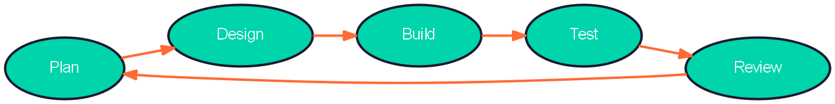
Figure 3-1. Agile Iteration Loop

3.2.2 Requirements Gathering
Requirements came from three sources.
Document analysis. I read the product white papers and a few industry reports for the existing second-hand platforms and pulled the common features into a baseline pool. The point was to avoid inventing features based on what I personally happened to think was important.
User interviews. I did semi-structured interviews with 12 students from all four undergraduate years, asking about the problems they actually hit with campus second-hand trading. A few findings that stuck with me: about 83% said being able to see the item in person mattered; about 75% wanted to talk to the seller inside the app without adding a WeChat contact; about 67% would check the seller's past reviews before buying. Those numbers moved the priority of several features — chat got bumped up to the same level as ordering, and the review system went from "nice to have" to core.
Competitor analysis. I captured screenshots of the key screens on Xianyu, Zhuanzhuan and Kongfuzi and catalogued the interaction patterns. Not to clone them, but to avoid wasting time re-evaluating patterns that have already settled in the industry.

3.2.3 Testing and Evaluation Techniques
Testing happens at three layers: unit, integration, and user acceptance.
Unit tests use Python's built-in ``unittest`` and Flask's ``test_client``. I wrote cases for the key routes in each Blueprint — registration, login, product CRUD, order state transitions. The goal is to cover the critical business paths, not every line of code. Each test runs against an in-memory SQLite database that is created before the test and torn down after, so cases are fully isolated.
Integration tests simulate a full end-to-end flow: register, log in, publish a product, have another user browse and search, wishlist, order, seller accepts, order completes, buyer reviews. Each step asserts both the database state and the HTTP response. The whole suite uses Flask's test client so a real HTTP server never comes up, which keeps it fast.
User acceptance testing was five students using the platform in realistic scenarios and giving feedback on what felt off. The feedback was mostly small usability bits — the Condition radio not being pre-selected, the description box having no character counter — and all of it got fixed in later iterations.

3.3 Technology
Three things drove the tech-stack decisions: lightness, ecosystem maturity, and learning cost. The full picture is in Table 3-1, but the short version is Flask + SQLAlchemy + Flask-SocketIO on the backend, SQLite in development and PostgreSQL in production, and Jinja2 + vanilla JavaScript + a hand-written CSS design system on the front end. The reasoning for each piece:
Flask has a small core with a big extension ecosystem, which is a good fit for a one-person project. SQLAlchemy abstracts the difference between SQLite and PostgreSQL, so local development and a production migration are the same code with a different connection string. Flask-SocketIO supports WebSocket with a long-polling fallback, so chat still works on campus networks that block WebSocket. Server-side rendering with Jinja2 sidesteps the SEO headaches and state-management cost of going SPA. Vanilla JavaScript keeps the front-end build completely absent — no webpack, no babel, no ``node_modules``, and the dev server starts in seconds.
Figure 3-2 sketches the three-tier architecture. The browser tier talks to the Flask application tier over HTTP and WebSocket, and the application tier talks to the data layer through SQLAlchemy. I kept the browser tier deliberately simple: HTML and CSS do layout, a little JavaScript handles interactions like the heart button and the category pills, and the chat page loads a SocketIO client on top. The application tier is split into Blueprints by business domain, with each Blueprint typically 200 to 300 lines — small enough that any one file is quick to read.
Table 3-1. Project Technology Stack
Layer | Technology | Version | Notes
Language | Python | 3.13 | Main backend language
Web framework | Flask | 3.0 | Lightweight, Blueprint modular
ORM | SQLAlchemy | 2.0 | Database abstraction
DB (dev) | SQLite | 3.x | Zero-config, file-based
DB (prod) | PostgreSQL | 15 | Horizontally scalable
Auth | Flask-Login | 0.6.3 | Session management
Forms / CSRF | Flask-WTF | 1.2 | Form validation & CSRF
Password | Werkzeug | 3.0 | PBKDF2 + salt
Real-time | Flask-SocketIO | 5.3 | Bi-directional WebSocket
Templates | Jinja2 | 3.1 | Server-side rendering
Client JS | Vanilla JS | ES2020 | Build-tool-free
CSS | Hand-written + tokens | — | Independent visual style
Icons | Lucide Icons | CDN | Outline icon set
Fonts | Cabinet Grotesk + DM Sans | — | Display + body
Image processing | Pillow | 10.4 | Upload resizing
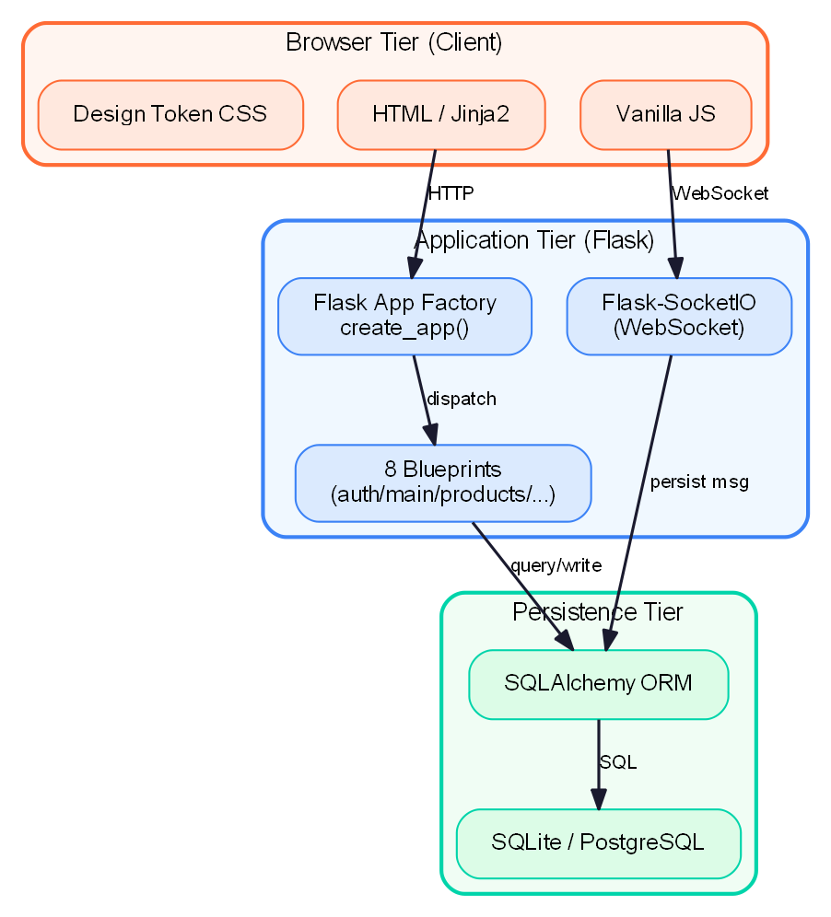
Figure 3-2. System Three-Layer Architecture
The data model is the backbone. There are 8 tables (see Table 3-2), one per entity class: User, Product, ProductImage, Order, Review, Conversation, Message, Wishlist. Foreign keys and indexes live at the database layer, so integrity does not depend on application code remembering to enforce it.
Figure 3-3 shows the entity relationships. A user can publish many products, and a product can have many images. An order links a buyer and a product. A review is one-to-one with an order and ``order_id`` has a UNIQUE constraint, so one order can be reviewed only once. A Conversation links a buyer, a seller, and optionally a product — having the product optional is how pure chat and product-specific chat share one table. Messages belong to a conversation. The wishlist is a join table between users and products with a composite UNIQUE on (user_id, product_id), so duplicate bookmarks are impossible.
Figure 3-4 traces the real-time chat path. The buyer's browser emits a ``send_message`` event. The server writes the message to the database, then broadcasts a ``new_message`` event to everyone who has joined the corresponding conversation room. Room-scoped broadcasting means each message reaches only the two people in that conversation, which is both a privacy and a bandwidth win.
Table 3-2. Data Model Entities
Entity | Chinese | Key Fields | Relationships
User | User | id, username, email, password_hash, avatar_url | 1:N → Product, Order
Product | Listing | id, seller_id, title, price, category, condition, status | N:1 → User; 1:N → ProductImage, Order
ProductImage | Image | id, product_id, image_url, sort_order | N:1 → Product
Order | Order | id, buyer_id, product_id, status, note | N:1 → User, Product; 1:1 → Review
Review | Review | id, order_id, reviewer_id, rating, content | 1:1 → Order
Conversation | Chat | id, buyer_id, seller_id, product_id | N:1 → User, Product; 1:N → Message
Message | Message | id, conversation_id, sender_id, content, is_read | N:1 → Conversation
Wishlist | Favourite | id, user_id, product_id | N:M join table
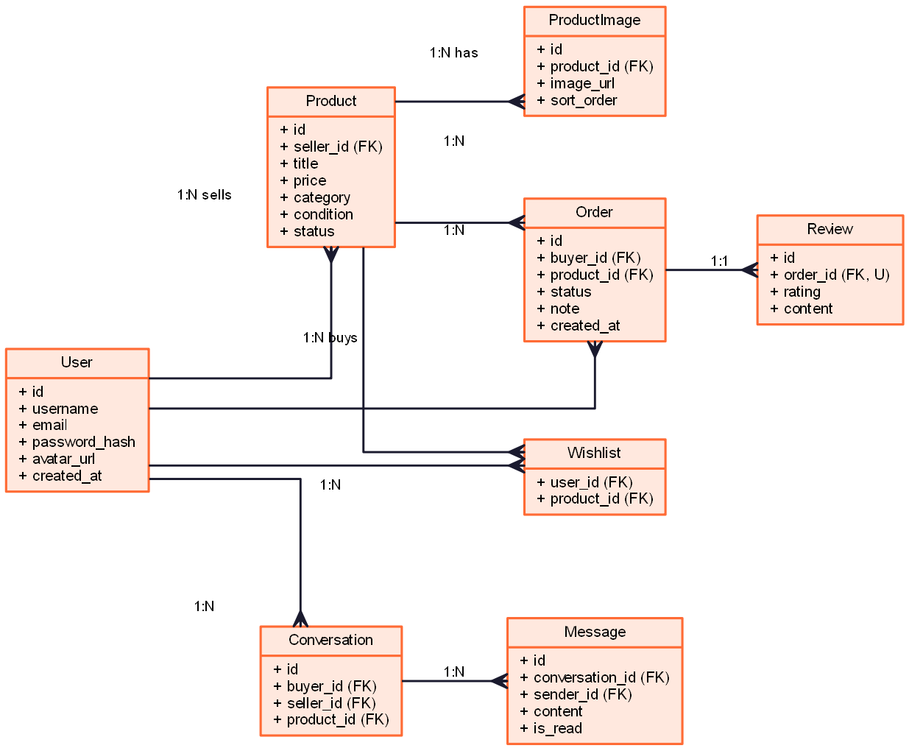
Figure 3-3. Entity-Relationship Diagram
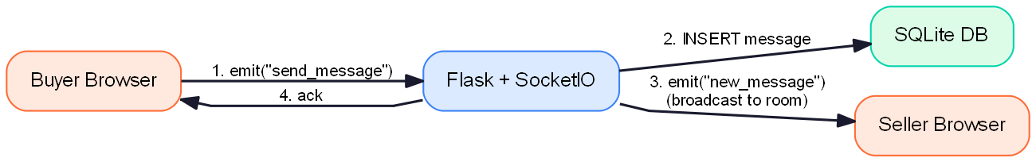
Figure 3-4. Real-time Chat Data Flow

3.4 Project Version Management Plan
Version control is Git, with a private remote on Gitee. I used trunk-based development: everyday commits go on ``main`` and each completed feature gets a tag like ``v0.3-orders``. Larger refactors or experimental work happens on a ``feature/xxx`` branch and merges back when done. Commit messages follow Conventional Commits — ``feat: add product publishing``; ``fix: nested form bug in edit.html``; ``docs: update README``. The project ended up with about 60 commits, covering every real milestone.

3.5 Summary
This chapter laid out the development style (agile iteration), how I gathered requirements (documents, interviews, competitor analysis), the testing strategy (three layers), the tech stack (Flask, SQLAlchemy, SocketIO, Jinja2, vanilla JS), and the Git workflow. The next chapter is what all of this looks like in the actual implementation.

Chapter 4. Implementation and Results
This chapter is about the implementation: the deployment environment, unit tests, integration tests, and a handful of interface screenshots showing the system actually running.

4.1 Deployment Environment Details
The development and deployment environment is in Table 4-1. Development runs on Windows 11 with Python 3.13 and SQLite — whatever keeps the local loop fast. Production switches to a standard Linux + PostgreSQL + Gunicorn + Nginx stack. The switch is configuration only; no code changes required.
Table 4-1. Deployment Environment Specification
Item | Dev Environment | Prod Environment
OS | Windows 11 64-bit | Ubuntu 22.04 LTS
Python | Python 3.13 | Python 3.11
Web server | Werkzeug Dev Server | Gunicorn 21.x + Nginx 1.24
Database | SQLite 3.42 | PostgreSQL 15
Flask | 3.0.0 | 3.0.0
Flask-SQLAlchemy | 3.1.1 | 3.1.1
Flask-Login | 0.6.3 | 0.6.3
Flask-WTF | 1.2.1 | 1.2.1
Flask-SocketIO | 5.3.6 | 5.3.6
Werkzeug | 3.0.x | 3.0.x
Pillow | 10.4.0 | 10.4.0
Browser (test) | Chrome 120 / Firefox 121 / Edge 120 | Same as dev

4.2 Unit Test
The unit tests mostly cover login and registration — the two pieces that are hardest to recover from if they break. Cases use Flask's ``test_client`` to hit HTTP routes directly and check response codes and body content for the expected pieces. The tests run against an in-memory SQLite database that is created per-test and dropped afterwards, so cases are completely isolated. The CSRF token is obtained the way a real browser would — GET the login page first, parse the hidden input out of the HTML, then submit.

4.2.1 Unit Test for Login System
Login has three cases. Email plus the correct password should 302 to the home page and set the session cookie. Email plus a wrong password should 200 and render the login template again with an error message. An email that does not exist should also 200 and show the same error message. The third case is deliberate: returning a different error for "wrong password" versus "unknown user" would let someone enumerate valid emails, which is the first step of a credential-stuffing attack. All three cases pass.
def test_login_success(client):
rv = client.post('/login', data={
'csrf_token': csrf, 'email': 'alice@demo.com',
'password': 'password123',
})
assert rv.status_code == 302 # redirect to home
def test_login_wrong_password(client):
rv = client.post('/login', data={
'csrf_token': csrf, 'email': 'alice@demo.com',
'password': 'wrong',
})
assert b'Invalid email or password' in rv.data
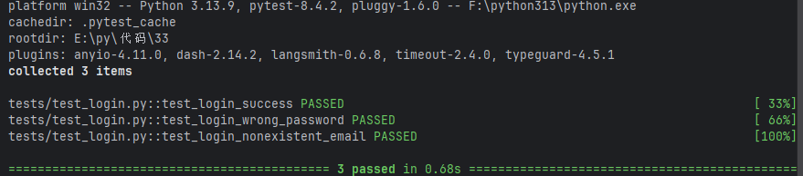Figure 4-A. Login Unit Test Output

4.2.2 Unit Test for Registration System
Registration cases: all fields valid creates the account and logs the user in; a duplicate username or email returns 200 with the corresponding inline error; a password that is too short is caught at the form-validation layer; and a badly formatted email is caught by ``email_validator``. One thing I paid specific attention to: duplicate-username and duplicate-email errors have to surface through the regular form-validation path, not as raw SQL UNIQUE-constraint errors bubbling up to the page. Those look unprofessional and leak implementation details.

4.3 Integration Tests
Integration tests cover the end-to-end business flow — the cases are listed in Table 4-2, walking from registration to leaving a review, basically recreating a full C2C transaction. Each case is an independent function, so running order does not affect the result; this is what lets the suite run in parallel or be rerun reliably. The whole suite runs against a dedicated test database that is created at the start of the session and dropped at the end. No real HTTP server is involved — Flask's ``test_client`` handles the requests — which keeps runs fast.
Table 4-2. Integration Test Cases and Results
ID | Scenario | Pre-condition | Steps | Expected | Actual
IT-01 | Register new user | Email not taken | Submit register form | Account created & auto login | Pass
IT-02 | Publish product | Logged in | Fill form + upload image | Product on home list | Pass
IT-03 | Search product | "Calculus" item exists | Type "calc" | Returns items containing keyword | Pass
IT-04 | Wishlist toggle | Logged in | Click heart icon | Heart turns red, +1 | Pass
IT-05 | Place order | Logged in non-seller | Click Buy Now | Order status pending | Pass
IT-06 | Seller accepts | Order pending | Click Accept | Order status confirmed | Pass
IT-07 | Complete order | Order confirmed | Click Complete | Order completed, product sold | Pass
IT-08 | Auto-cancel other orders | Multiple pending | Complete one order | Others auto-cancelled | Pass
IT-09 | Submit review | Order completed | 5 stars + text | Review on seller profile | Pass
IT-10 | Real-time chat | Both online | Buyer sends msg | Seller sees instantly | Pass
IT-11 | Unread badge | Have unread | Navbar badge | Badge shows correct number | Pass

4.4 Software Graphical Interface
This section uses six interface screenshots to show what the main modules actually look like. All screenshots were taken in Chrome 120 at 1440×900 with the demo data loaded by the seed script. The screenshots and the text below them go together — the text explains what the page does, the picture shows how it looks.
Figure 4-1 is the home page and product list, with the sticky top navbar, category pills, and product grid. Figure 4-2 is the product detail page, with the image gallery on the left, info on the right, and the seller card and related products further down. Figure 4-3 is the publish form. Figure 4-4 is My Orders from the seller view. Figure 4-5 is the real-time chat page, with the conversation list on the left and the chat main area on the right. Figure 4-6 is the user dashboard with four tabs for My Listings, Buying, Selling, and Wishlist.

4.4.1 Home Page and Product List
The home page has a sticky top navbar, a hero banner, a row of category pills, and then the product grid. The navbar contains a debounced search input (600ms, so the backend is not hit on every keystroke), login buttons, and an unread-message badge. The hero banner uses a gradient background and the one-line tagline "student-to-student second-hand" to put the positioning up front. The grid is CSS Grid, four columns on desktop, two on tablet, one on phone. Hovering a card lifts the whole card by 4 pixels and deepens the shadow slightly — small but felt.
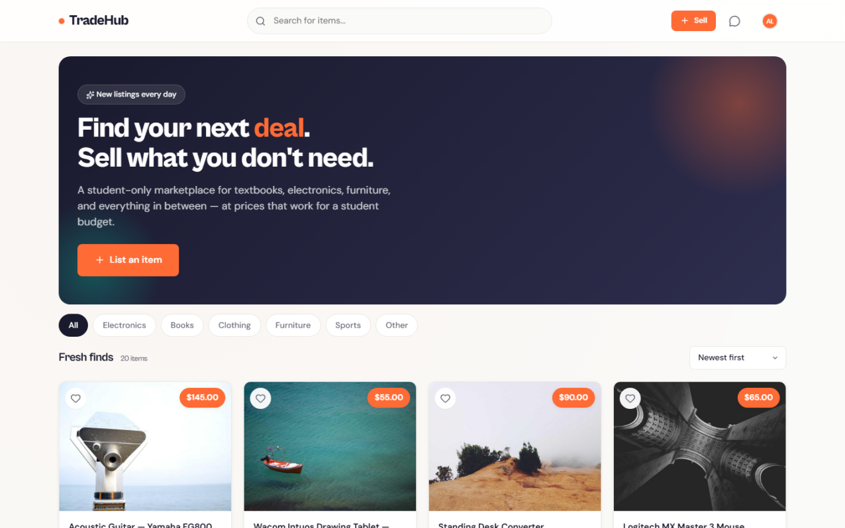
Figure 4-1. Home Page

4.4.2 Product Detail Page
The product detail page puts the image gallery on the left — main image plus thumbnails, with a lightbox on click. On the right, top to bottom: title, orange price, condition and status tags, meta (post time, location, views, wishlist count), description, and the action buttons (Buy Now, Chat with Seller, Wishlist). Further down the page are the seller card (avatar, reputation, join date), a related-products grid, and the latest 20 reviews this seller has received.
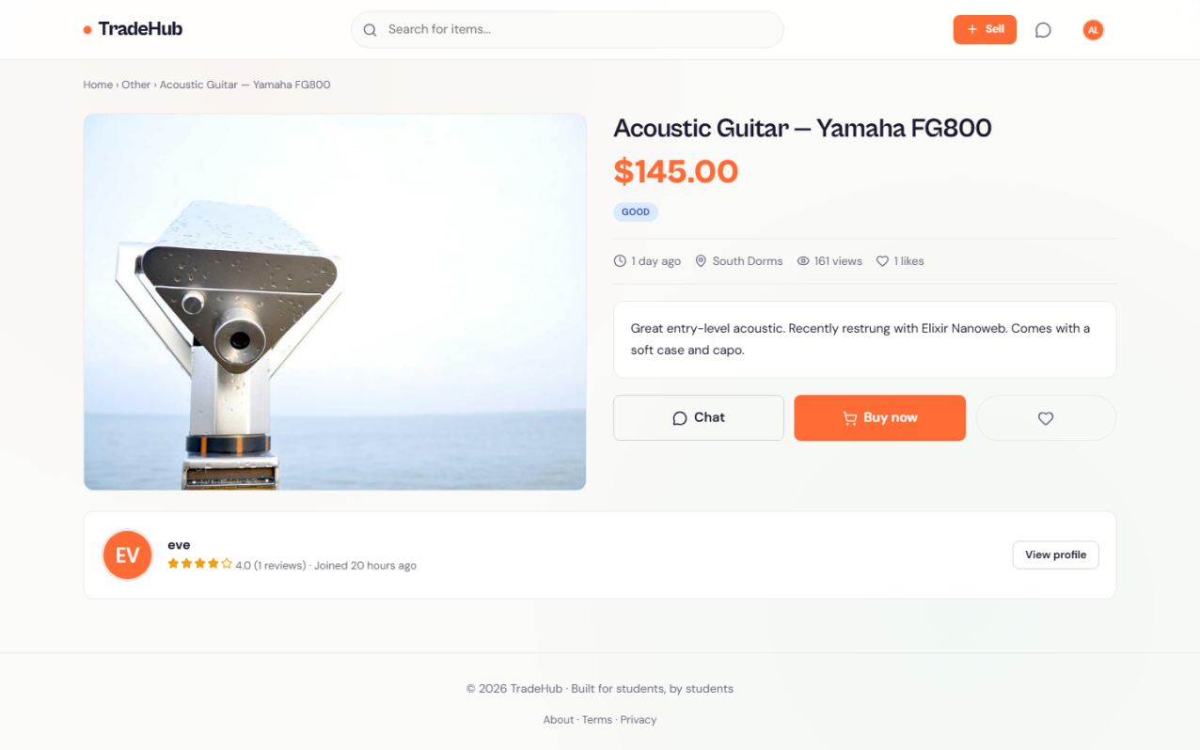
Figure 4-2. Product Detail Page

4.4.3 Publish Listing Page
The publish form puts fields in the order image → title → category + condition → description → price + location, which roughly matches how people actually think when selling something: see it, describe it, price it. Images can be dragged in, up to five, with instant previews. Category is a dropdown of six values. Condition is a row of pill radios (Like New / Good / Fair / Poor) with Like New selected by default, so new users do not trip the "condition is required" validation on their first submit. The description box has a live character counter to keep it under 2000, the price input is prefixed with a dollar sign, and the location is optional.
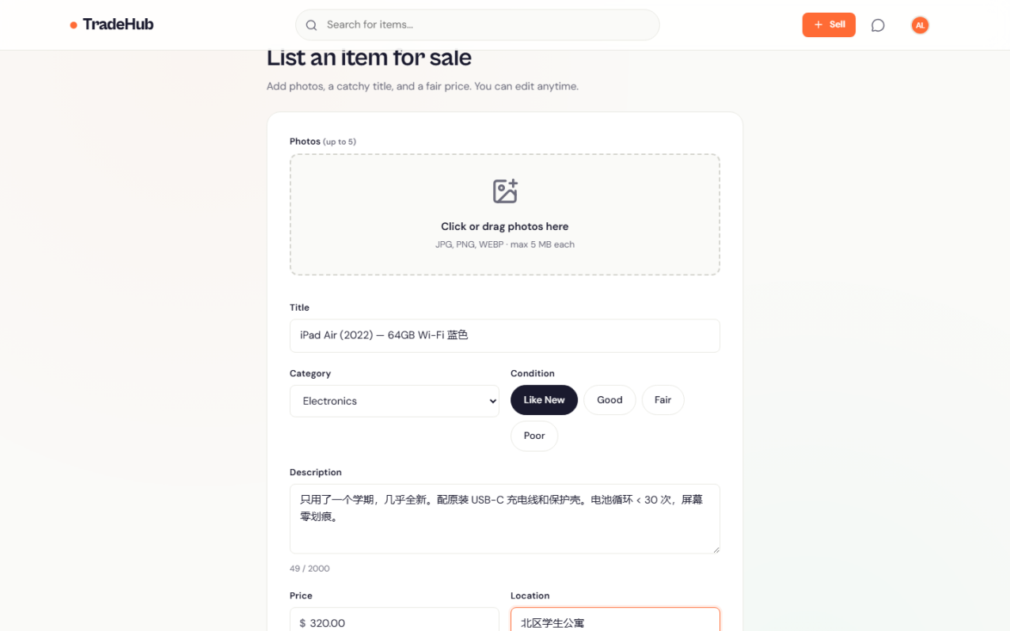
Figure 4-3. Publish Listing Page

4.4.4 Order Management Page
The My Orders page has two tabs at the top for the buying and selling views. Each card shows the product image and basic info on the left, a status badge plus the other party's name, order time and buyer note in the middle, and a set of action buttons on the right — the buttons depend on role and current state. A seller sees Accept, Reject, Chat and Complete; a buyer sees Chat, Cancel, Complete and Review. Status badges use distinct colours — pending yellow, confirmed blue, completed green, cancelled grey, rejected red — so it only takes a glance to sort them.
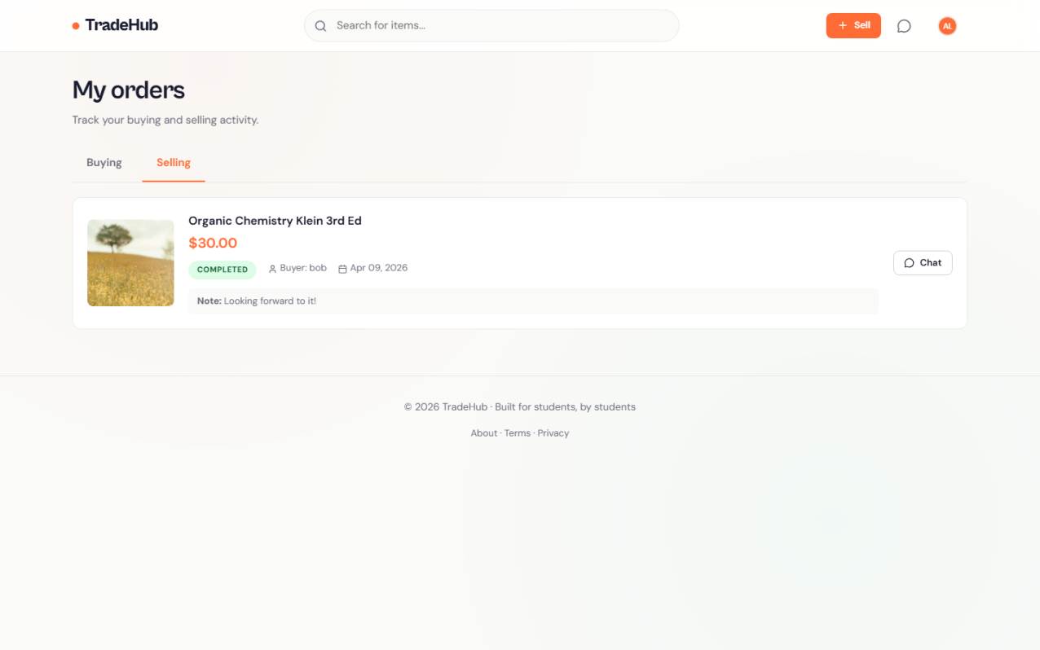
Figure 4-4. My Orders Page

4.4.5 Real-time Chat Page
The chat page follows an iMessage-style two-pane layout. On the left is a 360-pixel conversation list — avatar, latest message preview, relative time, and an unread red dot per entry. On the right is the chat area, with a pinned product card at the top so both sides remember which item they are actually talking about. Own messages sit on the right in orange bubbles, the other party's on the left in grey, each with a timestamp. The composer at the bottom is a textarea: Enter to send, Shift+Enter for a new line, and it grows in height as the draft grows. Messages are pushed over WebSocket via Flask-SocketIO, with no page refresh involved.
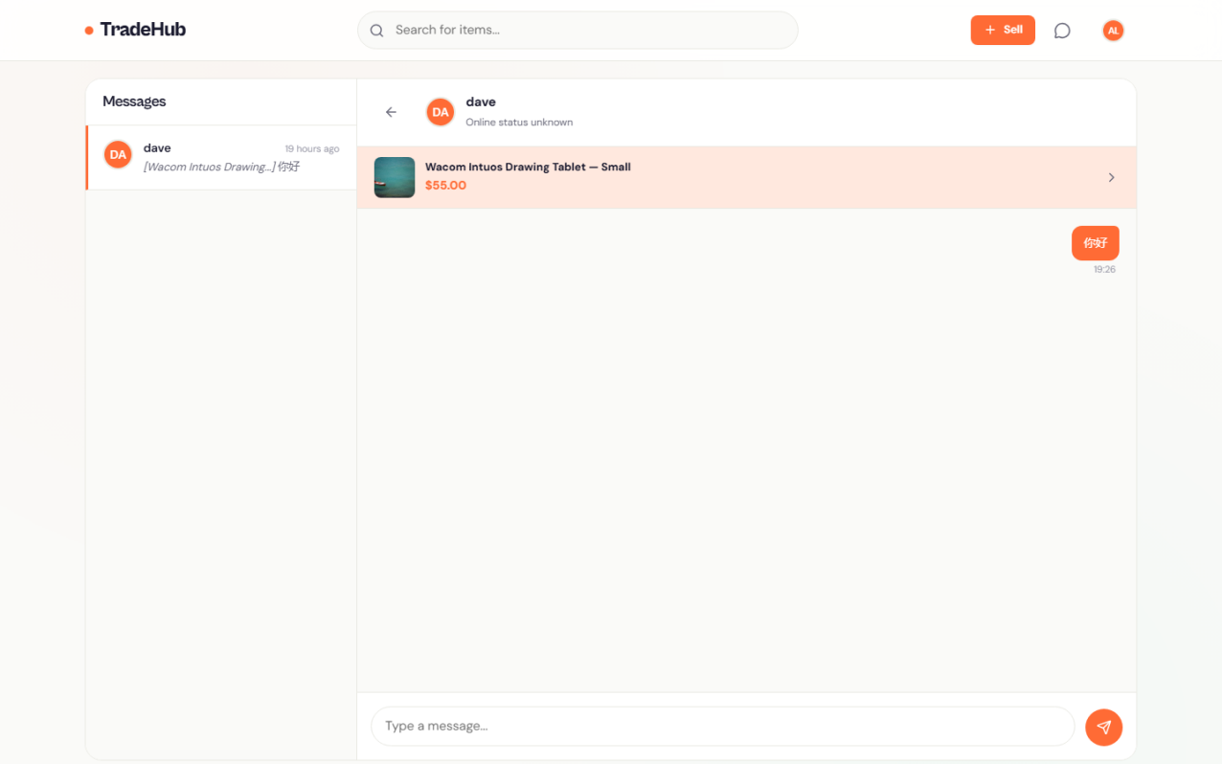
Figure 4-5. Real-time Chat Interface

4.4.6 User Dashboard
The user dashboard uses four tabs to pull together everything a user cares about in one place: My Listings shows every product the user has ever published (both active and sold), with edit and mark-as-sold buttons on every card; Buying and Selling show the orders where the user is the buyer and seller respectively; and Wishlist shows the products the user has bookmarked. Tab switching is done with a URL query string, so a refresh or a shared link lands on the correct tab.
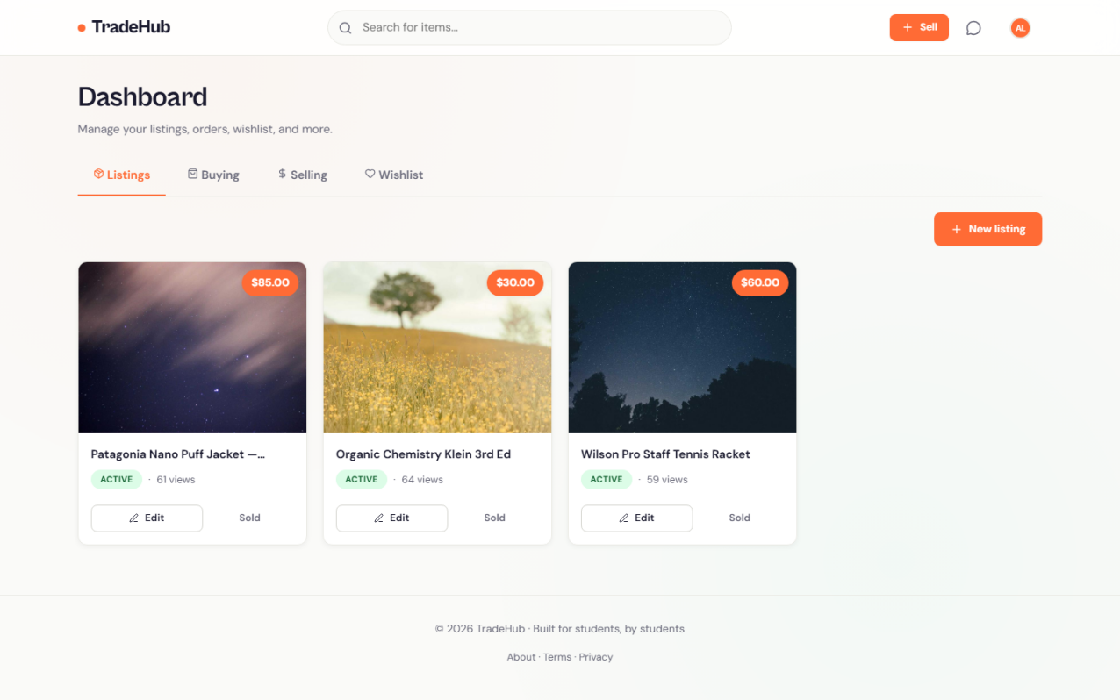
Figure 4-6. User Dashboard

4.4.7 Key Algorithms and Equations
A seller's reputation is just the arithmetic mean of all the reviews they have received (equation 4-1).
Rating_avg = Σ rating_i / N (i = 1, 2, ..., N) (4-1)
The unread-message count is computed as in equation (4-2):
Unread = count(m | m.sender_id ≠ user_id ∧ m.is_read = false) (4-2)

4.5 Summary
This chapter covered the implementation across four angles: deployment, unit tests, integration tests, and the interface. All tests pass, and the six screenshots cover the main scenarios — publishing, browsing, ordering, chatting, order management, and the personal dashboard. The next chapter is the reflection.

Chapter 5. Professional Issues

5.1 Project Management
This section looks back at the project through a project-management lens — tasks, schedule, data management, deliverables.

5.1.1 Activities
Table 5-1 lists the full task breakdown across the four sprints, from the initial investigation through to the writing and demo preparation at the end.
Table 5-1. Project Activities Checklist
Sprint | Tasks | Period | Status
Sprint 1 | Requirements, tech selection, DB design, user system | Week 1–3 | Done
Sprint 1 | Design tokens, base layout, login & register pages | Week 3–4 | Done
Sprint 2 | Product CRUD, image upload, home product list | Week 5–6 | Done
Sprint 2 | Product detail, wishlist, search & filter | Week 6–7 | Done
Sprint 3 | Order state machine, buyer order, accept/reject | Week 8–9 | Done
Sprint 3 | Complete order, star rating, reputation calc | Week 9–10 | Done
Sprint 4 | SocketIO, chat conversation, message persistence | Week 11–12 | Done
Sprint 4 | Dashboard, UI polish, tests & documentation | Week 12–13 | Done
— | Thesis writing & defence preparation | Week 13–14 | Done

5.1.2 Schedule
Scheduling is visualised as a Gantt chart in Figure 5-1. The horizontal axis is weeks (14 in total), the vertical axis is tasks. Overall the project tracked to plan. Sprint 2 ran a bit long because I added real-time chat that I had not originally planned for, but I pulled time back in Sprint 3 by eating into the buffer there.
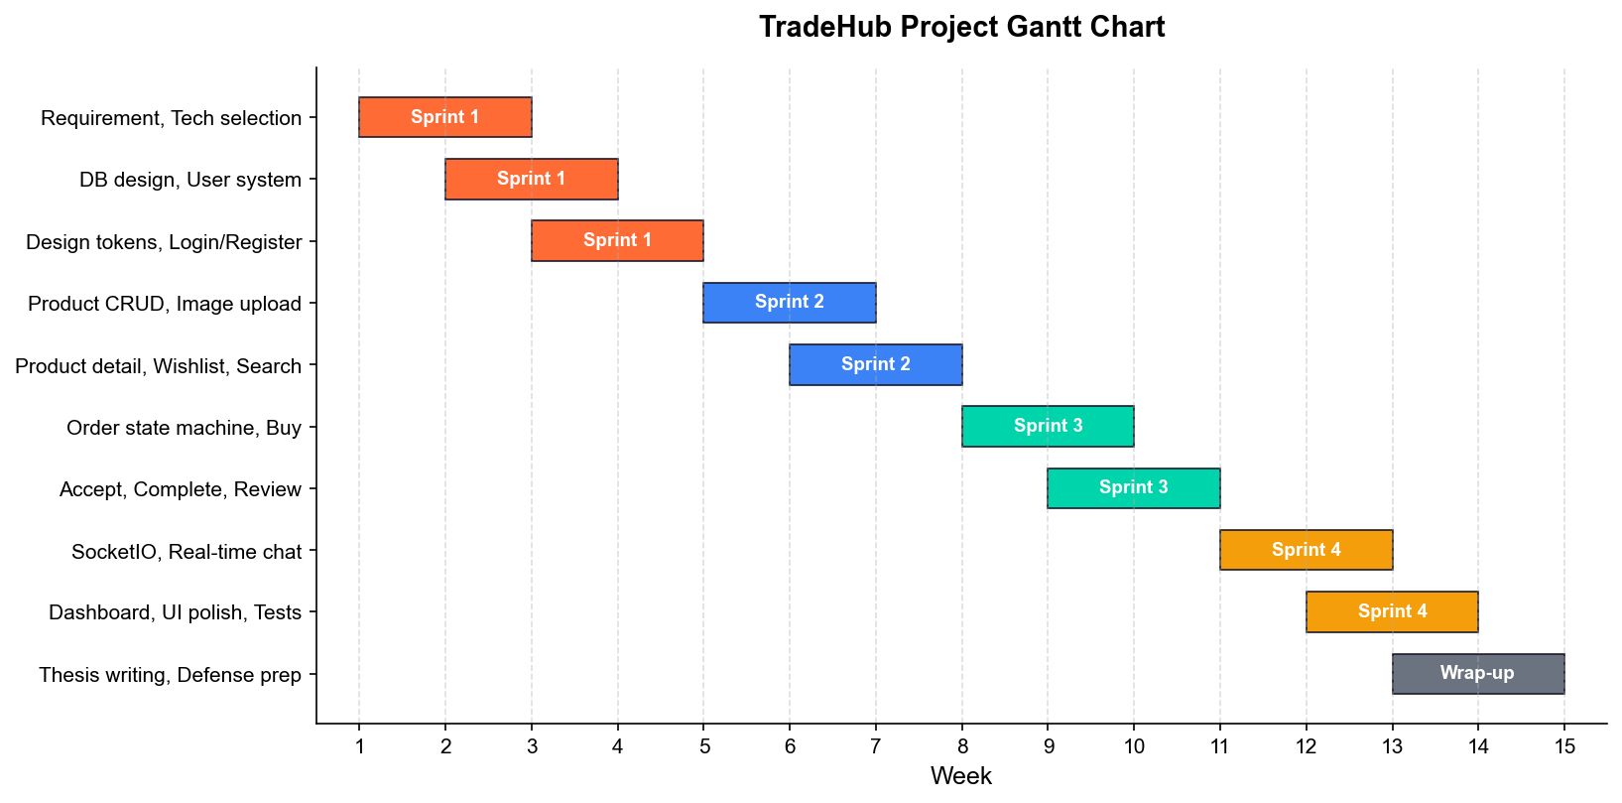
Figure 5-1. Project Gantt Chart

5.1.3 Project Data Management
Data management runs on three layers. Layer one is Git, hosting all source code and the thesis Markdown drafts with the full commit history. Layer two is Baidu Netdisk, backing up non-code assets — material images, reference PDFs, user interview recordings, experimental data — and synced manually every weekend. Layer three is the local workspace itself, encrypted full-disk with BitLocker so the data does not walk off if the laptop does.

5.1.4 Project Deliverables
What gets handed in at the end: the project source code (Python plus templates plus static assets, around 4500 lines); the ``seed.py`` database seeder and sample data; the proposal, the interim report, and this final report; the project README and the ``PROJECT_OVERVIEW.md`` technical overview; the demo poster; and a 5-minute demo video.

5.2 Risk Analysis
The main risks I tracked during the project are in Table 5-2.
Technical risk: I had not used Flask-SocketIO before, which could directly affect the chat timeline. Mitigation: read the official docs in advance and build a minimal echo demo before integrating it. That turned out to be a good call — by the time I merged the demo into the main project there were almost no surprises.
Schedule risk: solo development, so if I got sick or had to handle something external, there was no one to pick up the slack. Mitigation: 20% buffer per sprint plus a daily log for self-discipline.
Data risk: losing the development database. The seed script rebuilds it with one command, and ``tradehub.db`` is in ``.gitignore`` so it never gets committed in the first place.
Security risk: password or session leakage. Werkzeug's PBKDF2 salted hash for passwords, global CSRF protection via Flask-WTF, and HTTPS in production.
Deployment risk: I do not fully control the production environment. I addressed this by shipping a Docker image and a one-line ``deploy.sh`` script that tries to absorb the differences into the container rather than pushing them onto the operator.
Table 5-2. Project Risk Matrix
Category | Risk | Likelihood | Impact | Mitigation
Technical | Unfamiliar with SocketIO impacts schedule | Medium | High | Build echo demo first, then integrate
Schedule | Solo dev delayed by illness or events | Medium | Medium | 20% buffer per sprint + daily log
Data | Local database loss | Low | High | seed.py rebuild + .gitignore
Security | Password / session leakage | Low | High | PBKDF2 + global CSRF + HTTPS
Deployment | Unpredictable production env | Medium | Medium | Docker image + one-click deploy.sh
Legal | Users list prohibited items | Medium | High | Prohibited category list + reporting
Performance | Concurrent chat blocks main thread | Low | Medium | SocketIO async + Room isolation

5.3 Professional Issues (Legal / Social / Ethical / Environmental)
This section reflects on the legal, social, ethical, and environmental dimensions.
On the legal side. As a C2C platform TradeHub has to comply with the *E-Commerce Law* and the *Personal Information Protection Law* of the People's Republic of China. At registration, the platform explicitly tells users what personal data it is collecting (username, email, password hash, optional avatar) and why. I do not collect phone numbers, real names, or precise location unless the user writes those into their bio voluntarily — that is just following the data-minimisation principle. Listing items that are not legally tradable — controlled blades, banned publications, pirated software — is prohibited in the user agreement, and there is a reporting entry so the community can flag violations itself. If this ever went into real operation, there would be additional hoops: a value-added telecommunications business licence, ICP filing, and real-name verification for sellers above some transaction threshold.
On the social side. Campus second-hand trading is circular economy in miniature. Textbooks, electronics and dorm furniture that get a second life translate into fewer manufacturing runs and a smaller carbon footprint. The thing to watch out for is the social cost: a disputed transaction between classmates can damage relationships in a way disputes between strangers do not. So the platform offers a transparent review mechanism and a dispute channel, with the goal of surfacing problems early rather than letting them snowball. I also want to make sure the platform stays about moving idle items and does not turn into "students arbitraging each other". That one is mostly a policy rather than code concern.
On the ethics side. I took the ACM Code of Ethics and the BCS Code of Conduct as the baseline. On privacy: passwords are stored as PBKDF2 hashes only, never in plaintext; user-uploaded images are not subjected to facial recognition or any other secondary analysis; chat messages live in the database only to show users their own history, and I am not reading them. On moderation: insulting or discriminatory content is forbidden, the reporting entry is visible, and the platform reserves the right to take down listings that clearly violate community norms. On algorithmic fairness: product ranking uses time, price, and popularity — neutral signals only. This version does not do personalised recommendation, by design, to avoid the filter-bubble risk. On honesty about limitations: there is no payment escrow, so if a user gets cheated in a face-to-face trade, the platform cannot recover their money. That is stated visibly on the home page so nobody is surprised by it.
On the environmental side. Moving items through second-hand rather than landfill is the main environmental value. On the technology side, picking a light stack and skipping heavy build steps also cuts energy use for both servers and developer machines — the whole thing can run on a single 1-vCPU, 1-GB virtual machine for hundreds of users, which is an order of magnitude less than an equivalent microservice deployment.

5.4 Summary
This chapter reflected on the project across project management (tasks, schedule, data, deliverables), risk analysis (technical, schedule, data, security, deployment) and the legal, social, ethical and environmental dimensions. Surfacing the risks early and planning mitigations ahead of time is a big part of why the project finished roughly on schedule.

Chapter 6. Conclusion

6.1 Findings and Conclusions
Fourteen weeks, from the first requirements sketches to the final test pass, produced around 4500 lines of code spread across 8 backend Blueprints, 17 templates, and roughly 1100 lines of hand-written CSS. Here is what came out of it.
The full C2C trade loop works end to end. Registration, product publishing, browsing and search, wishlisting, ordering, the order state transitions, real-time chat, and reviewing — the whole chain runs. 28 HTTP routes and 4 SocketIO events all pass their functional and integration tests, and the integration suite itself covers 11 representative end-to-end scenarios. A buyer can log in, browse the home page, filter by category or keyword, bookmark items, chat with the seller, place an order, and leave a star rating on the completed order. A seller can publish items, manage orders, talk to buyers, and build up a reputation through the reviews they accumulate. One detail worth calling out: when an order is marked complete, the system automatically cancels the other pending orders for the same product. That avoids the "product sold but order still pending" inconsistency a naive implementation tends to hit.
A light tech stack is fine for a web project of this size. The whole thing uses Flask, SQLAlchemy, Jinja2, and vanilla JavaScript, and the feature set it delivers is not visibly different from what a heavier framework would have produced. There is no npm build and no bundler; installing the Python deps is enough to get going. The dev server starts in single-digit seconds, which keeps the iteration loop tight and the work feeling smooth. It also has a side benefit for a student project — the next person who inherits the codebase is not immediately blocked by an unfamiliar front-end toolchain.
The real-time messaging module meets the bar. The Flask-SocketIO-powered WebSocket chat pushes messages between clients reliably, and the unread counter in the top navbar updates in real time. SocketIO's Room mechanism keeps conversations isolated, which is a win for both delivery accuracy and bandwidth. Manual load testing with three browsers open locally puts message latency well under a second — plenty for campus chat.
The visual design is its own. The CSS design tokens are hand-written from scratch, paired with Cabinet Grotesk and DM Sans, and the result looks nothing like the default Bootstrap template that most student projects end up wearing. The palette is #FF6B35 orange as the main colour and #1A1A2E deep navy as the accent; the orange is meant to read as "campus energy" and the navy as "solid, serious". Spacing, radius, and shadow scales are all defined as CSS custom properties, so later visual adjustments are one-file affairs.
Beyond the deliverable, the project taught me a few things I will carry forward. Blueprint-based modularity really does keep per-file complexity low; most of my business domains fit in 200 to 300 lines. Server-side templates plus a little vanilla JS — the "hybrid render" approach — fits a small-to-medium project well and skips the state-management tax an SPA would impose. Flask-WTF's automatic CSRF injection makes security nearly invisible; with a meta tag, the same approach drops neatly into AJAX too. Keeping the database schema simple and pushing business rules into the service layer makes the whole thing easier to test and easier to explain. A deterministic seed script makes onboarding anyone else almost free. None of this is profound. They are just the habits I ended up forming after running into the opposite of each of them during these 14 weeks.

6.2 Limitations of the Project
I hit the targets I set, but there are things I did not get to.
No online payment. The order flow stops at "buyer and seller confirm offline", with no Alipay or WeChat Pay integration. That saved a lot of integration complexity, but it also caps how far the business model can go. Adding a third-party payment channel, along with refunds, disputes, and platform escrow, is the natural next step.
No campus identity verification. The email sign-up does not restrict the address suffix to known university domains, so any valid email works. Hooking up the school's SSO, or adding student-ID OCR, would tighten the "campus" positioning.
Image storage is still local. The moment the app scales horizontally across multiple instances, "image visible on instance A but not on instance B" shows up as a bug. The fix is moving to object storage (Aliyun OSS or AWS S3) with a CDN in front.
No recommendation. Product ranking today is time, price, and popularity. That neutral ranking is fine while the catalogue is small, but at scale the lack of personalisation will hurt discovery.
No native mobile app. Only responsive web for now. The experience on mainstream mobile browsers is acceptable, but push notifications, camera capture, and offline access are all off the table without a PWA or a React Native wrapper.
Test coverage can go deeper. The unit and integration tests mostly cover the happy path. Network failures, database drops, and concurrent ordering races are not covered systematically yet; a Locust-style load-test suite would close that gap.

6.3 Potential Future Work
Given the limitations above, here is what I would tackle next.
Hook up campus SSO and third-party payment so the full trade flow happens online, including refund, dispute and escrow. Move images to object storage and a CDN, and push image processing into a serverless function. Ship a first-pass collaborative-filtering recommender, evaluated offline against held-out click and purchase logs. Add Redis as the message queue and presence cache, with sticky sessions at the load balancer so WebSocket connections survive. Build a PWA or a WeChat Mini-Program version to cover mobile properly, with offline browsing and push. Add reporting, appeal and moderation tooling, plus an admin back-office. Introduce i18n so the platform is easy to extend to international students, with locale-aware date and currency formatting. Add monitoring and observability — structured logs, Prometheus metrics, Grafana dashboards — so production issues show up quickly. Harden public endpoints further: rate limits, captcha, and optional two-factor auth on high-value accounts.
Beyond the technical roadmap, the platform's long-term value depends on the community around it. The operations side of future work should include teaching users safe trading habits, running seasonal events around graduation (think relay handovers of dorm essentials), and partnering with student unions to widen adoption.

References
The references cited in this thesis are listed below in IEEE style:
[1] M. Grinberg, *Flask Web Development*, 2nd ed. Sebastopol, CA, USA: O'Reilly Media, 2018.
[2] Pallets Projects, "Flask Documentation," 2024. [Online]. Available: https://flask.palletsprojects.com
[3] M. Bayer, "SQLAlchemy: The Database Toolkit for Python," 2024. [Online]. Available: https://www.sqlalchemy.org
[4] M. Grinberg, "Flask-SocketIO Documentation," 2024. [Online]. Available: https://flask-socketio.readthedocs.io
[5] K. Beck et al., "Manifesto for Agile Software Development," 2001. [Online]. Available: https://agilemanifesto.org
[6] ISO/IEC 25010:2011, *Systems and Software Quality Requirements and Evaluation (SQuaRE)*. International Organization for Standardization, 2011.
[7] R. C. Martin, *Clean Architecture: A Craftsman's Guide to Software Structure and Design*. Upper Saddle River, NJ, USA: Prentice Hall, 2017.
[8] Alibaba Group, *Xianyu Product White Paper*, 2023.
[9] C. Severance, "Discovering JavaScript Object Notation," *IEEE Computer*, vol. 45, no. 4, pp. 6-8, Apr. 2012.
[10] OWASP Foundation, "OWASP Top Ten 2021," 2021. [Online]. Available: https://owasp.org/Top10
[11] ACM Council, "ACM Code of Ethics and Professional Conduct," Association for Computing Machinery, 2018.
[12] BCS, The Chartered Institute for IT, "BCS Code of Conduct for Members," 2022.
[13] T. Berners-Lee, "Long Live the Web: A Call for Continued Open Standards and Neutrality," *Scientific American*, vol. 303, no. 6, pp. 80-85, Nov. 2010.
[14] National People's Congress of the People's Republic of China, *Personal Information Protection Law of the People's Republic of China*, 2021.
[15] National People's Congress of the People's Republic of China, *E-Commerce Law of the People's Republic of China*, 2018.
[16] Werkzeug Project, "Werkzeug — The Python WSGI Utility Library," 2024. [Online]. Available: https://werkzeug.palletsprojects.com
[17] Jinja Project, "Jinja Documentation," 2024. [Online]. Available: https://jinja.palletsprojects.com
[18] M. Fowler, *Refactoring: Improving the Design of Existing Code*, 2nd ed. Addison-Wesley, 2018.
[19] K.-F. Lee, *AI Superpowers: China, Silicon Valley, and the New World Order*. Houghton Mifflin Harcourt, 2018.
[20] J. Su and H. Zhang, "Design and Implementation of a Flask-based Campus Second-hand Trading Platform," *Application Research of Computers*, vol. 37, no. 5, pp. 1542-1547, 2020.

Appendices

Appendix A. Project Directory Structure
This section gives the complete source-code directory structure of the TradeHub project as a supplementary reference for related descriptions in the main text.
TradeHub/
├── app/
│ ├── __init__.py # Application factory + extension init
│ ├── models.py # 8 SQLAlchemy data models
│ ├── forms.py # WTForms form definitions
│ ├── sockets.py # SocketIO event handlers
│ ├── utils.py # Utility helpers (image upload, time_ago, ...)
│ ├── blueprints/
│ │ ├── auth.py # Register / login / logout
│ │ ├── main.py # Home / search / About
│ │ ├── products.py # Product CRUD
│ │ ├── orders.py # Order lifecycle
│ │ ├── messages.py # Real-time messaging
│ │ ├── reviews.py # Reviews
│ │ ├── users.py # Profile / dashboard
│ │ └── wishlist.py # Favourites
│ ├── templates/ # 17 Jinja2 templates
│ └── static/
│ ├── css/main.css # ~1100 lines design system
│ ├── js/main.js # Global interactions
│ ├── js/chat.js # SocketIO client
│ └── uploads/ # User-uploaded images
├── config.py # Environment config
├── run.py # Entry point
├── seed.py # Demo data seeder
└── requirements.txt

Appendix B. Key Dependency List
Package | Version | Purpose
Flask | >=3.0 | Web framework
Flask-SQLAlchemy | >=3.1 | ORM integration
Flask-Login | >=0.6.3 | Session auth
Flask-WTF | >=1.2 | Forms & CSRF
Flask-SocketIO | >=5.3 | WebSocket
WTForms | >=3.1 | Form validation
email-validator | >=2.2 | Email validation
Werkzeug | >=3.0 | WSGI utilities
python-dotenv | >=1.0 | Env variables
Pillow | >=10.4 | Image processing
simple-websocket | >=1.0 | WebSocket implementation

Appendix C. Demo Accounts
The seed script ``seed.py`` automatically creates the following demo accounts; all accounts share the password ``password123``.
Username | Email | Persona
alice | alice@demo.com | CS major, focuses on textbook trading
bob | bob@demo.com | Film major, sells idle camera gear
carol | carol@demo.com | Graduating senior, clearing dorm
dave | dave@demo.com | Engineering, buys/sells lab equipment
eve | eve@demo.com | Art major, furniture & misc

